Root Booking API Design
- Purpose
Delivers a .NET application for room-booking API with readable and maintainable code, sensible HTTP and database design, validation and error handling, correct conflict handling, proportional performance decisions and tests.
- Goals
- List all available rooms.
- List a room's reservations with bounded filtering.
- Create one reservation without accepting an overlap.
- Provide focused unit and integration tests.
- Non-goals
In this phase does not implement authentication, ownership, recurring reservations, Drafts or holds, edit/cancel, idempotency, check-in, UI clients, door displays, QR codes, rate limiting, distributed cache, messaging, telemetry, HA, or deployment infrastructure.
- Overview architecture
The overall layered design defines a server-centric, layered architecture for the room-booking API. Its dependency path is API Controllers -> Business Contracts -> Business Services -> EF Core Data Access -> SQLite. PC and mobile clients appear only as external consumers of the HTTP contract; no client application is implemented or tested in this solution.
- External client context: PC and mobile clients exchange HTTPS JSON with the API using conceptual client models.
- API presentation layer: RoomController and ReservationController own HTTP binding, validation entry points, status codes, headers, and Problem Details.
- Business contract boundary: IRoomService and IReservationService expose the application operations required by the controllers without HTTP or persistence concerns.
- Business service layer: RoomService and ReservationService implement room and reservation use cases, including schedule validation and stored time-overlap decisions.
- Data access layer: EF Core DbContext, mappings, and query definitions own database access and provider conversions; no generic repository wraps EF Core.
- Database: File-backed SQLite stores the Rooms and Reservations tables, constraints, indexes, and migration history.

The three model groups keep transport, business, and persistence representations independent:
- Client Model: RoomData and ReservationData represent conceptual public JSON values. Problem Details remains a transport envelope.
- Domain Model: RoomModel and ReservationModel use business-oriented values such as typed identifiers, DateOnly, TimeOnly, and UTC creation time.
- Entity Model: RoomEntity and ReservationEntity contain EF Core persistence values, including StartMinute, EndMinute, keys, relationships, and mapped SQLite values.

- Class Diagram
The following class diagram defines the planned classes, interfaces, result types, model ownership, and static dependencies inside that structure. Operation signatures in the diagram express the logical inputs and outputs; ASP.NET Core and asynchronous wrapper types are omitted where they would obscure layer ownership.
- API contract
All successful responses use application/json. Problems use application/problem+json. POST requires Content-Type: application/json. JSON request property names are exact camelCase; unmapped fields are rejected.

Room response schema
Field | Type | Description
id | positive integer | Room identifier
name | string | Unicode room name
capacity | positive integer | Maximum nominal capacity
location | string | Trimmed physical location, such as floor and area
description | String or null | Optional trimmed room description

Reservation response schema
Field | Type | Description
id | positive integer | Reservation identifier
title | string | Trimmed opaque Unicode meeting title
date | YYYY-MM-DD string | Booking date
start | HH:mm string | Inclusive slot start
end | HH:mm string | Exclusive slot end
createdAt | UTC ISO 8601 string | Server creation instant

  - List available rooms
API Route: GET /api/v1/rooms
- The endpoint has no query parameters.
- Every room is returned, ordered by name.
- The endpoint does not inspect reservations and makes no availability claim.
Success: 200 with an array of room responses.

  - List room’s reservations
API Route: GET /api/v1/reservations?room={roomId}&date={date}
- roomId must be positive and identify an existing room.
- date is required and must use exact YYYY-MM-DD, malformed values return 400
- Only reservations on the requested date are returned, ordered by start time.
Success: 200 with an array of reservation responses. An existing room with no reservations on the requested date returns an empty array.
Unknown room: 404 ROOM_NOT_FOUND.

  - Get a reservation
API Route: GET /api/v1/reservations/{id}
- id must be positive integer, malformed values return 400.
Success: 200 with the reservation response.
Not Found: 404 RESERVATION_NOT_FOUND when absent.

  - Create reservation
API Route: POST /api/v1/reservations
Request:
{
“room”: 235,
"title": "Candidate interview",
"date": "2026-10-05",
"start": "09:30",
"end": "10:15"
}

Validations:
- roomId is positive integer and exists in room repository.
- All the body fields are required; explicit null is invalid.
- title is trimmed, contains 1-200 Unicode characters, and contains no disallowed control character.
- Date/time values obey the exact schedule contract.
- Start must be strictly after current host-local time.
- Unmapped JSON fields and unsupported media types are rejected.
Success: 201 Created, reservation response.
Errors: 400, 404, 409, 415, or 500 as defined below.

  - Error contract
All application-generated failures use RFC 7807. Exception messages, SQL, connection details, and another reservation's ID or title are never returned.
{
"type": "urn:room-booking:error:validation-error",
"title": "The request is invalid.",
"status": 400,
"detail": "Correct the invalid fields and retry.",
"instance": "/api/v1/rooms/1/reservations",
"code": "VALIDATION_ERROR",
"traceId": "00-...",
"errors": {
"startTime": ["startTime must use HH:mm."]
}
}

code, traceId, and errors are Problem Details extensions. errors is present only for field validation.

HTTP | Code | When
400 | VALIDATION_ERROR | Binding, malformed JSON, strict JSON, route/query/body, range, or business validation failure
404 | ROOM_NOT_FOUND | Requested room does not exist
404 | RESERVATION_NOT_FOUND | Requested reservation does not exist
409 | ROOM_TIME_CONFLICT | Create finds a same-room/date time overlap
415 | UNSUPPORTED_MEDIA_TYPE | POST is not application/json
500 | INTERNAL_ERROR | Unexpected server error with safe fixed prose
A client-aborted request does not synthesize a new response after cancellation.

- Implementation
The reservation creation flow collaborates across the five logical components for the single-request interaction with the validation rules:
- Validate the request body.
- Verify the requested room exists.
- Verify the same-room/date overlap reservation, return 409 ROOM_TIME_CONFLICT when a stored interval overlaps.
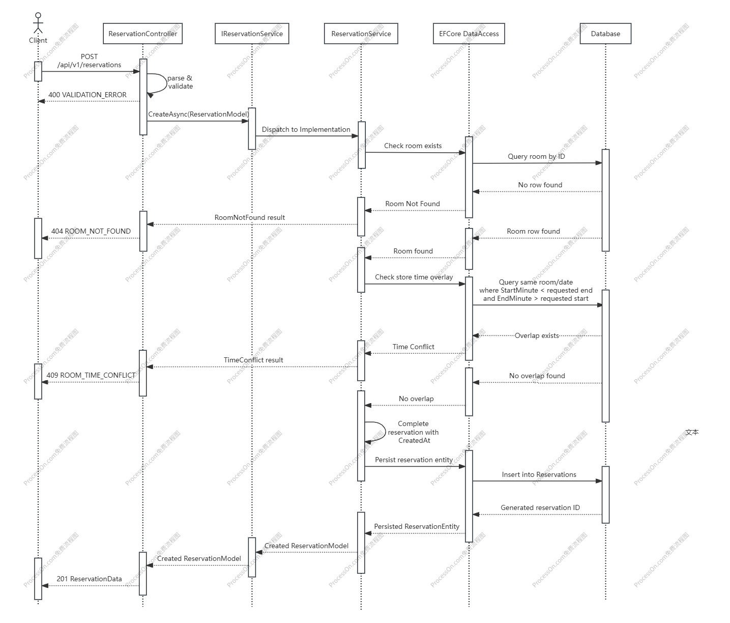

Reservations conflict only when room and date match and their half-open intervals overlap:
existing.StartMinute < requested.EndMinute
AND requested.StartMinute < existing.EndMinute

Therefore [10:00,11:00) and [11:00,12:00) are adjacent and valid.

The overlap response is privacy-minimized: it identifies the requested room/date/slot but never discloses the existing reservation.

- Data dictionary
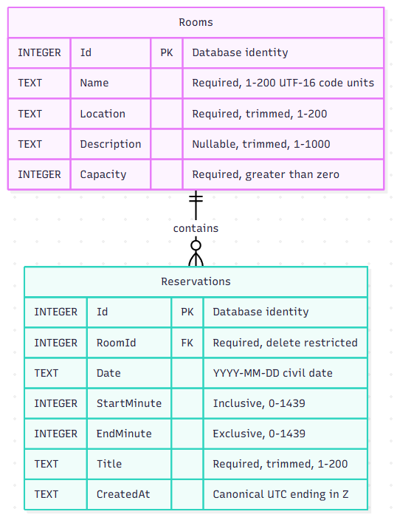
- Table: Rooms
Entity: RoomEntity
Purpose: Catalog of reservable rooms.
Lifecycle: Seeded by the initial migration; read-only through the API.
Sensitivity: Internal business catalog, not personal data.
Columns
Field Name | Purpose | C# type | SQLite type | Nullable
Id | Identifier | int | INTEGER PK | No
Name | Display name | string | TEXT | No
Location | Physical location | string | TEXT | No
Description | Human-readable details | String? | TEXT | Yes
Capacity | Nominal capacity | int | INTEGER | No

- Table: Reservations
Entity: ReservationEntity
Purpose: One confirmed reservation for one room, business date, and same-day half-open time slot.
Lifecycle: Inserted by POST
Sensitivity: Title may contain sensitive user-entered business content.
Columns
Field Name | Purpose | C# type | SQLite type | Nullable
Id | Identifier | int | INTEGER PK | No
RoomId | Reserved room | Int | INTEGER | No
Date | Booking date | DateOnly | TEXT | No
StartTime | Inclusive start | TimeOnly | INTEGER | No
EndTime | Exclusive end | TimeOnly | INTEGER | No
Title | Meeting title | string | TEXT | No
CreatedAt | Creation instant | UTC DateTime | TEXT | No

Indexed columns: RoomId, ReservationDate, StartTime, EndTime

- Technology key points
Runtime: .NET 10 + ASP.NET Core
Persistence: EFCore 10 + SQLite
Date Format: exact YYYY-MM-DD
Time Format: exact 24-hour HH:mm
Tests: xUnit and file-backed SQLite integration tests

- Performance decisions
- Read queries use AsNoTracking, server-side predicates/projections, async calls, and propagated cancellation.
- One composite index supports room/date/start overlap filtering and stable schedule ordering while covering the residual end-minute value.
- Maintainability rules
- Validation and Problem Details mapping are centralized; controller actions do not duplicate try/catch blocks.
- Class ownership and dependencies follow the layered class diagram;
- Client and Domain Models are immutable sealed records and public schemas are documented in OpenAPI.
- API controllers remain thin and delegate business behavior through their service contracts.
- Domain parsing/overlap policy and other logics are pure and unit-testable.

